Acceptance Testing
UAT Execution & Report Submission
Date | 08 October 2026
Team ID | [TEAM ID]
Project Name | Auto Ticket Classification Using ServiceNow Flow Designer
Maximum Marks | 4 Marks

1. Purpose of Document
The purpose of this document is to briefly explain the test coverage and open issues of the Auto Ticket Classification Using ServiceNow Flow Designer project at the time of the release to User Acceptance Testing (UAT).
2. Defect Analysis
This report shows the number of resolved or closed bugs at each severity level, and how they were resolved
Resolution | Severity 1 | Severity 2 | Severity 3 | Severity 4 | Subtotal
By Design | 0 | 0 | 0 | 1 | 1
Duplicate | 0 | 0 | 0 | 0 | 0
External | 0 | 0 | 0 | 0 | 0
Fixed | 0 | 0 | 1 | 1 | 2
Not Reproduced | 0 | 0 | 0 | 0 | 0
Skipped | 0 | 0 | 0 | 0 | 0
Won't Fix | 0 | 0 | 0 | 0 | 0
Totals | 0 | 0 | 1 | 2 | 3

3. Test Case Analysis
This report shows the number of test cases that have passed, failed, and untested
Section | Total Cases | Not Tested | Fail | Pass
Ticket Creation | 3 | 0 | 0 | 3
Dependent Choice | 4 | 0 | 0 | 4
Flow Classification | 8 | 0 | 0 | 8
Email Notification | 2 | 0 | 0 | 2
Security (Access Control) | 3 | 0 | 0 | 3
Totals | 20 | 0 | 0 | 20

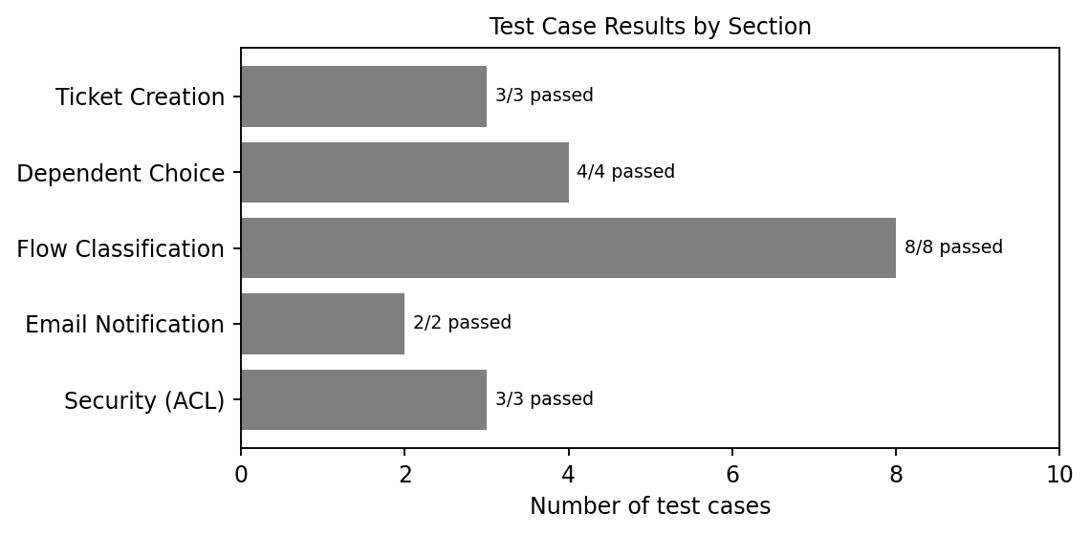
Note: Test case numbering follows the Functional & Performance Testing document (TC-01 to TC-20); the UAT scenarios (TC-001 to TC-008) are a subset of the same functionality.

